THE LAST MAMBABATOK OF THE KALINGAN TRIBE

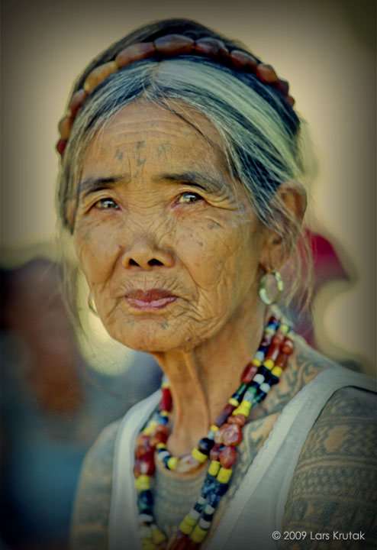

Body tattooing has been a part of Kalinga’s culture, where male warriors traditionally got tattoos, which symbolizes their bravery towards killing and winning battles. The more tattoos signifies their strength as a warrior. While for women, it symbolizes beauty and elegance

In the village of Buscalan is where you can find the oldest and the last Filipino artist who’s known for her majestic skills towards pagbabatok (an ancient art of tattooing) which she inherited from her father. Whang-Od lost her love in a logging accident at the age of 25, which made her dedicate her life tattooing, being the last practitioner of an ancient art that is thousand years old.

Today, this kind of art is slowly fading due to modern living, where young people are no longer interested in embracing the tattooing works. Before, Whang-Od tattoos headhunters and women of the Butbut tribes in Buscalan Kalinga, later on, she applies this art to tourist who visits their village. But Whang-Od brought back the ancient art after being featured on the ***Discovery Channel*** by **Larks Krutak,** a tattoo anthropologist. From his documentation, the practice of batok was discontinued in the 1940s due to headhunters being killed during World War II. One of the last warrior who still wear the Kalinga tattoo of his ancestors is Lakay Miguel. He was a war veteran who earned most of his tattoos fighting against the Japanese soldiers.

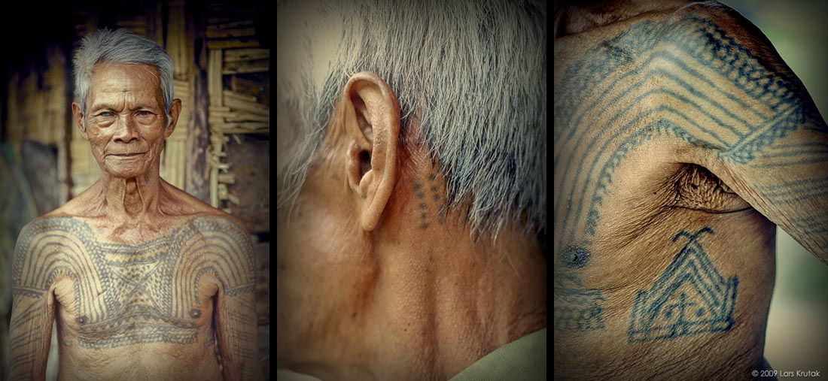

This show made a huge amount of interest, people from the Philippines and all over the word come visits her and to get laid by a thorn from pomelo or calamansi tree which is attached to a piece of bamboo as her needle, and uses pastry ink made from soot which is a mixture of a charcoal and water.

Whang-Od’s pambabatok is an example of Kalinga’s dying practice that must be preserved before it is too late.